Memo: Floor models Coca-Cola Freestyle (9000,9100,8000 and 8100) Extended Shutdown (72 Hours or more) Re-open Procedures

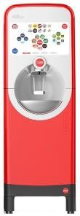
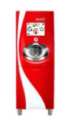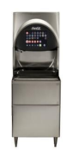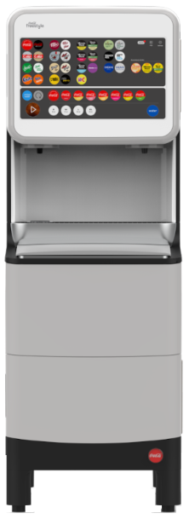

We understand that business needs are changing rapidly in the food service environment. As a result of an extended shutdown your Coca-Cola Freestyle dispenser may require additional steps to begin normal operation again. The following procedures provide additional guidance for your 9000/9100 and 8000/8100 dispenser(s). Should you need additional help or support, please contact Coca-Cola at 1-800-241-COKE (2653). We appreciate your continued partnership and business!
Basic Cleaning
The following helpful parts for the basic cleaning protocols are available through Coca-Cola Freestyle Small Parts Program.
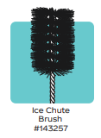
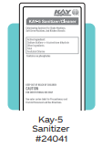
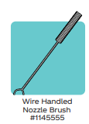
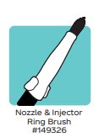

Basic cleaning protocols for re-open include:
•
- Clean and sanitize the ice bin and lid.
- If an ice maker is installed, follow the specific manufacturer guidelines for cleaning of ice maker.
- Follow established cleaning procedures for ice chute and exterior surfaces. (see video link at end of document if help is needed on this step)
Unclogging the Nozzle
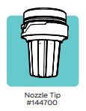
- As a result of the extended down time and reduced dispenser usage, more extensive procedures are recommended for the nozzle injector ring
and nozzle tip in order to clear clogs and ensure quality beverages are pouring for guests.
  - Remove the nozzle tip and soak it in warm water.
  - While the nozzle tip is soaking:
    - Wet both ends of the angled nozzle brush in hot water.
    - Use both ends of the brush and clean the
nozzle injector ring vigorously at an angle. A stabbing motion can be used
to remove clogs from the holes. The blue ring in picture 1 below notes the location of holes. Picture 2 also shows the location of the nozzle injector ring holes for scrubbing.
    - Soak a clean rag or paper towel in hot water and hold it against the nozzle injector ring for 10 seconds and squeeze water into the holes
    - Repeat these steps as often as necessary to loosen clogs
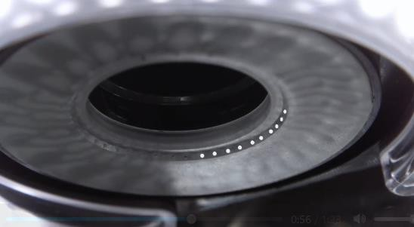
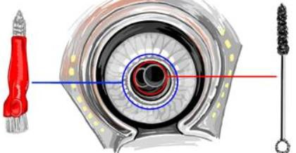
Perform Daily Nozzle Cleaning
1
2

Water and Carbonation Systems
The following internal and backroom components illustration may be helpful in identifying equipment during this next section of procedures.
9000
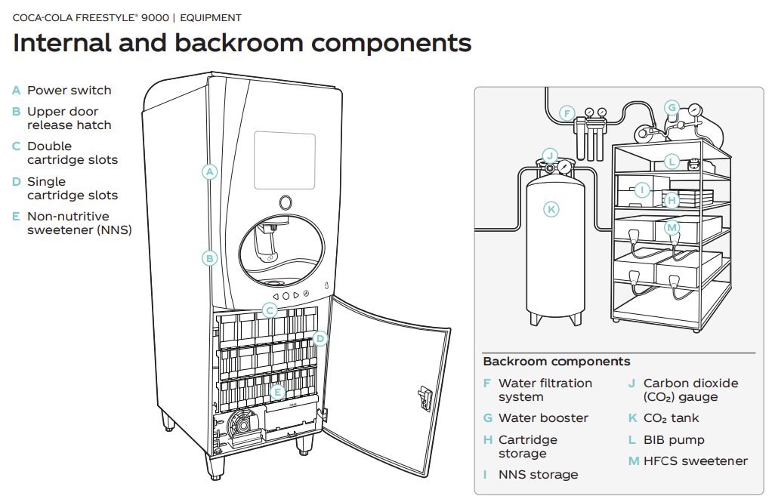

9100
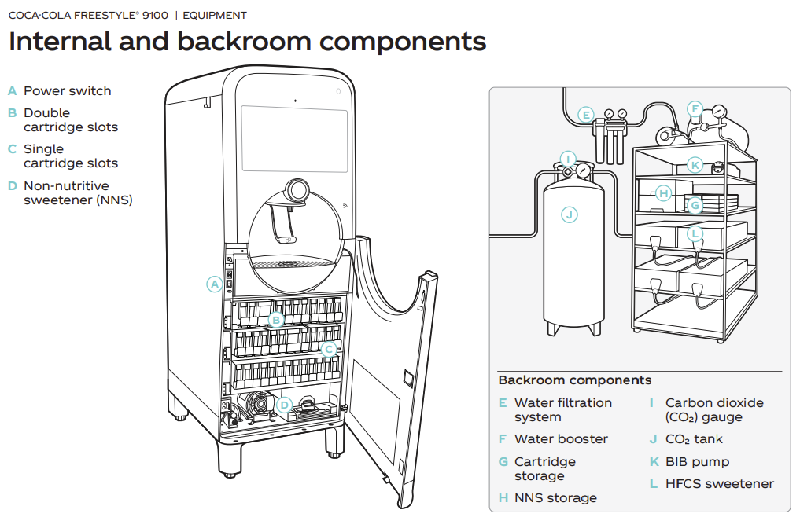

8000
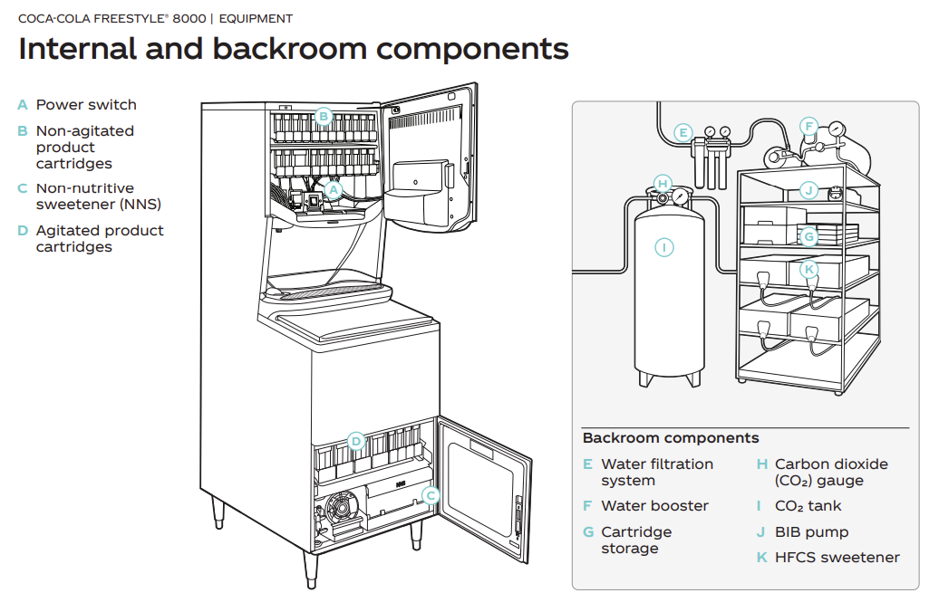

8100

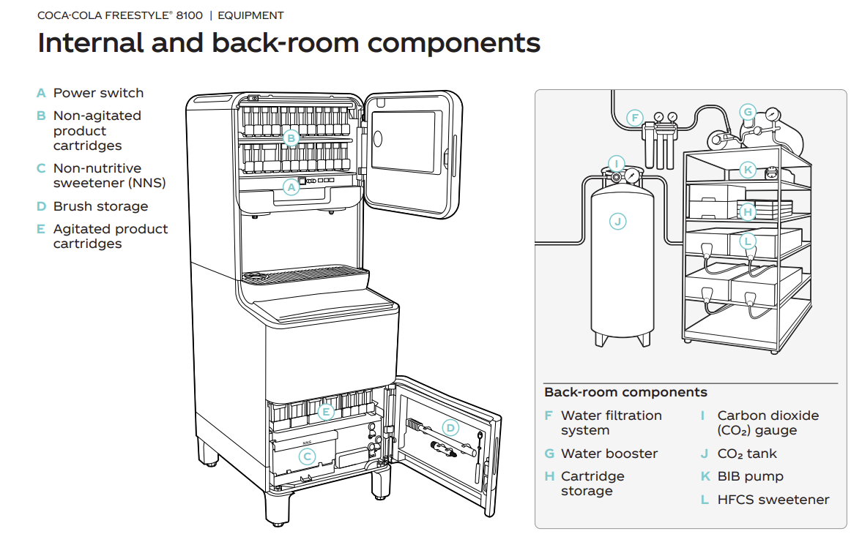

- IN THE BACK ROOM:
  - Follow the manufacturers recommendations on returning the water filter system into service.
  - Turn on the water supply to dispenser and ice maker.
  - Turn on the CO₂ source at the regulator.
  - Plug in the water booster.
  - Follow the manufacturers recommendations on returning ice maker to service, if applicable.

- AT DISPENSER:
  - Ensure the ice bin is full of ice.
  - Turn on the CO₂ valve in the lower cabinet - (8000, 9000 and 9100 are on the left side, and 8100 is on the right side).
    - Since the dispenser is powered off, for 9000/9100 the door will need to be opened manually to access the power button.
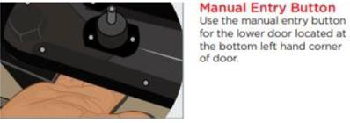
    - Engage the manual latch at the lower left of the bottom door.

    - For the 8000/8100, simply pull the door open.

  - Plug in dispenser, if unplugged from the wall outlet
  - Power on the dispenser with the green power switch
Ice and First Test Pour
- Check that the ice maker is working and re-set per manufacturing instructions, if needed. If it was turned off, turn on ice maker or manually fill the ice bin with ice.
- Navigate to the consumer mode screen on the dispenser.

8000/8100 9000/9100
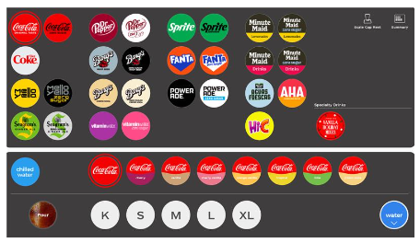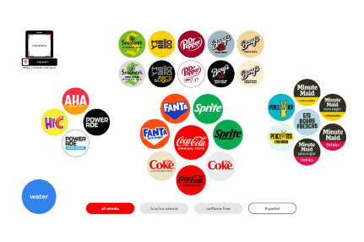
- Pour enough still water to fill a 32-ounce cup 4 times (or a total of 128 ounces).
- Pour enough carbonated/unflavored AHA water to fill a 32-ounce cup 4 times (or a total of 128 ounces). This may require more than one pour.
Ingredients
- Check the HFCS (High Fructose Corn Syrup) enjoy by date. Replace if empty or past the enjoy by date. Prime from the crew dashboard.
- Check the NNS (Non-Nutritive Sweetener) enjoy by date. Replace if empty or past the enjoy by date. Prime from the crew dashboard.

8000/8100
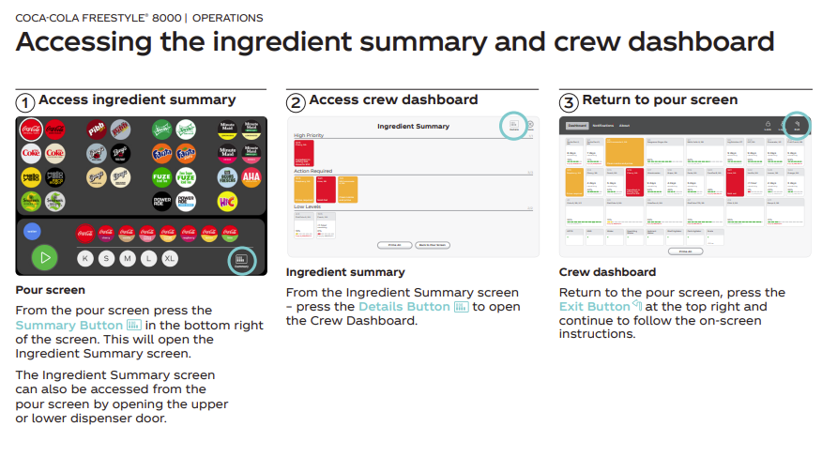
9000/9100
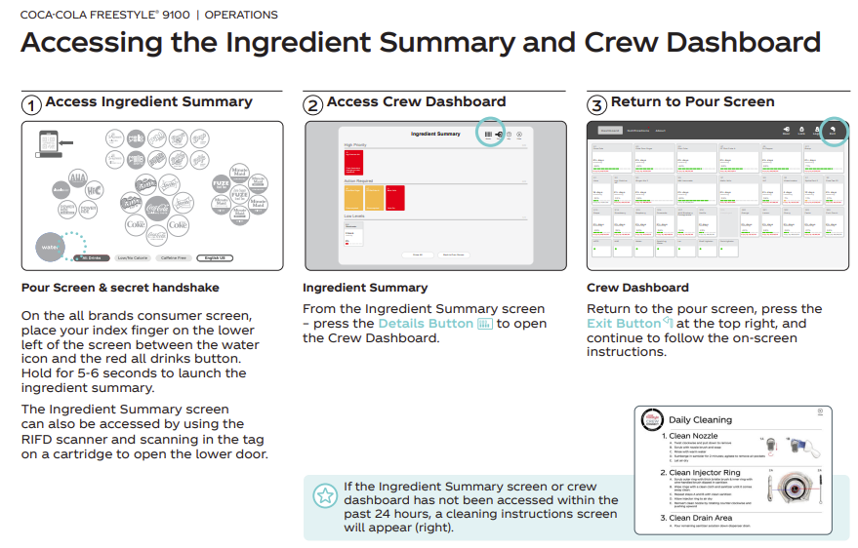
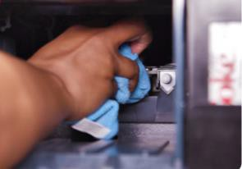
- Check ingredient quantity and enjoy by date. Replace if necessary. Follow the prompts on the screen to prime the ingredients replaced.
- Ingredients should not have been removed, but if there are empty slots, please follow the ingredient map available on the crew dashboard and be sure to clean/sanitize probes (see image on the right) and insert cartridges in the proper location.
- Do a test pour on beverages, being sure to include diet drinks.

Additional Cleaning Step
- Perform daily cleaning and sanitization of the nozzle injector ring and nozzle tip.
Taste Test
- Taste several beverages.
NOTES:
- Carbonation requires cold temperatures. If the ice maker was turned off or the manual fill bin empty, it may take a few hours before the drinks taste like they have enough carbonation.
- If the cartridge is not empty and the beverage has an off taste it may be necessary to repeat the nozzle injector ring steps as discussed in the Unclog the Nozzle section.

